PROOF OF WORK COMPLETED
SMELTER IGNITION UPGRADE (2026)
PO-5502335406

PAGES FIRST PASS (UNCOMPLETED) : 18 PAGES
PAGE COMPLETED : 18 PAGES
PAGES REMAINING : 5 PAGES
PERCENTAGE COMPLETED: 78%

SIGNATURES OF APPROVAL:

TABLE OF CONTENTS
1 Overview 3
1.1 Overview 3
1.2 HT 3
2 Pyro Furnance 3 4
2.1 Control 4
2.2 Temperature 4
2.3 Hydraulic Pack 5
2.4 Transformer 5
2.5 Slag Granulation 6
3 Pyro Furnance 4 6
3.1 Control 6
3.2 Temperature 7
3.3 Hydraulic Pack 7
3.4 Transformer 8
3.5 Slag Granulation 8
4 Pyro Furnance 5 9
4.1 Control 9
4.2 Temperature 9
4.3 Hydraulic Pack 10
4.4 Transformer 10
4.5 Slag Granulation 11
5 Utilities 11
5.1 Conc Silo 11
5.2 Lime Pyro Feed 12
5.3 Conc Vessel 12
5.4 Cooling 13
5.5 Lime Feeding Furnance 13
5.6 Conveyor Monitoring 14

Overview

Overview
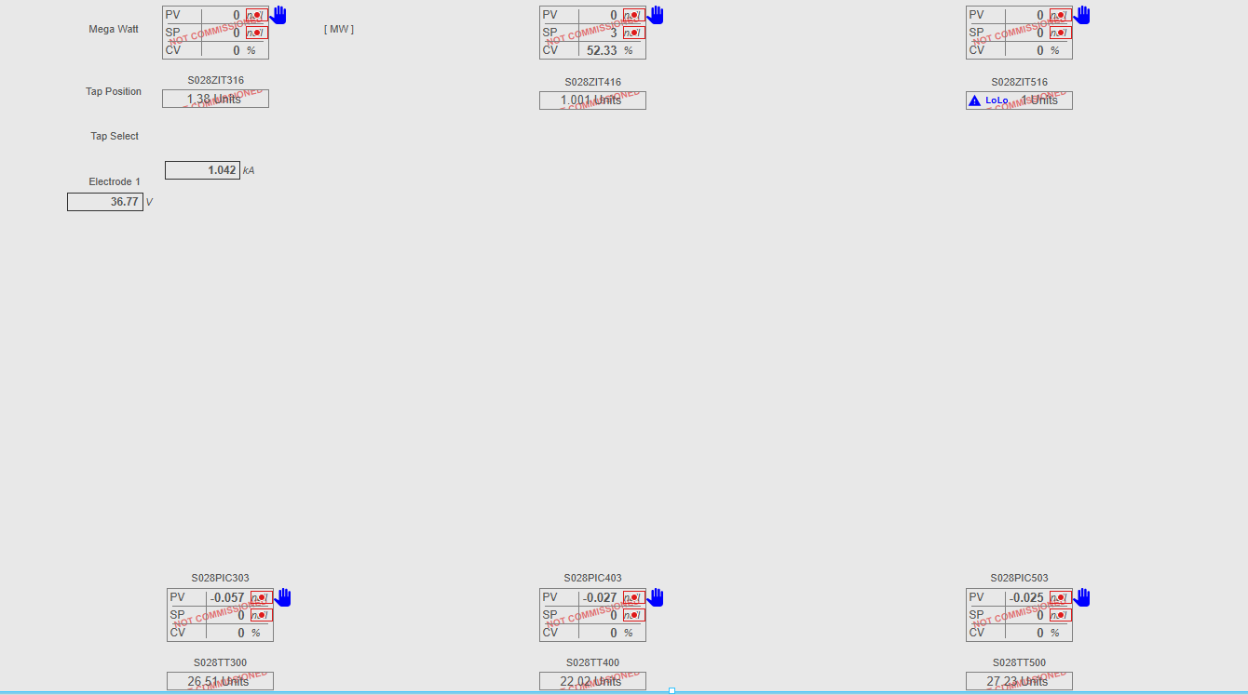

HT
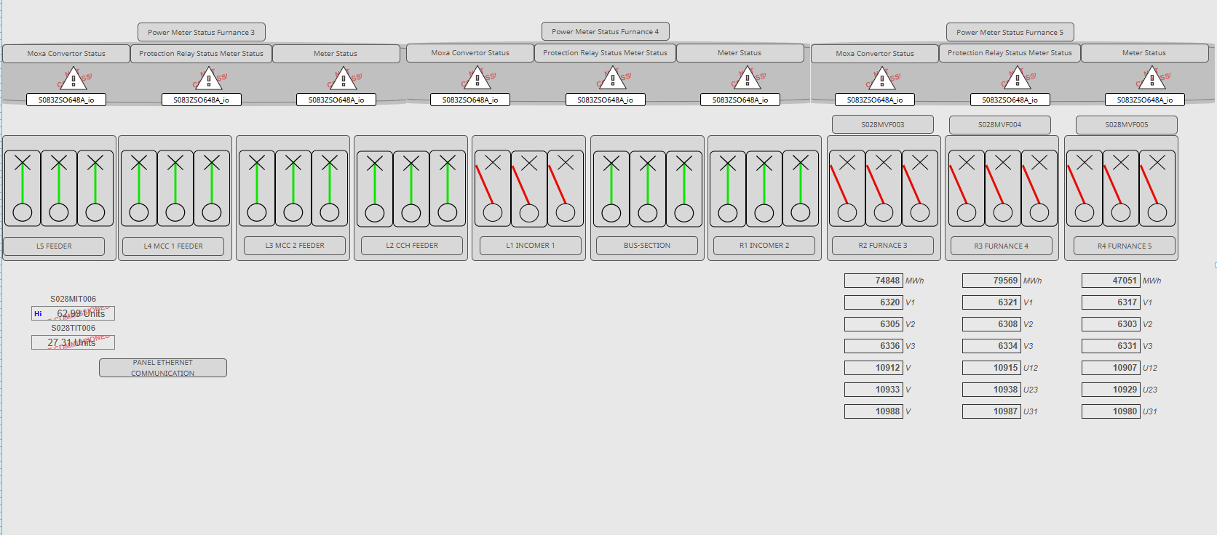

Pyro Furnance 3

Control
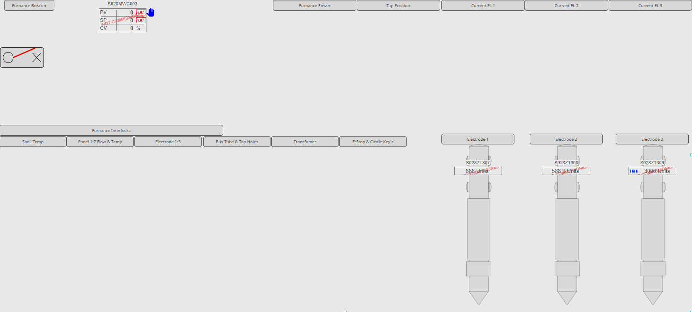

Temperature
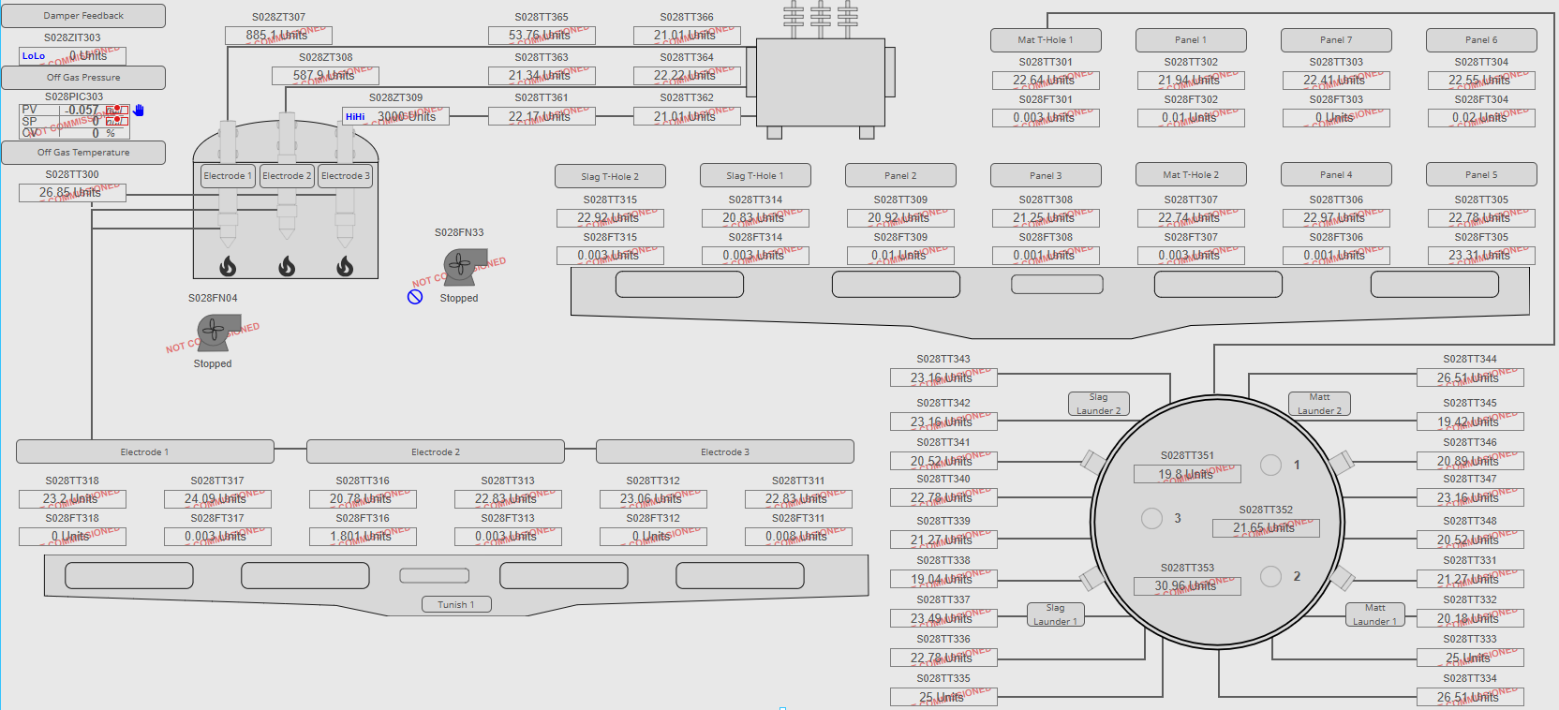

Hydraulic Pack
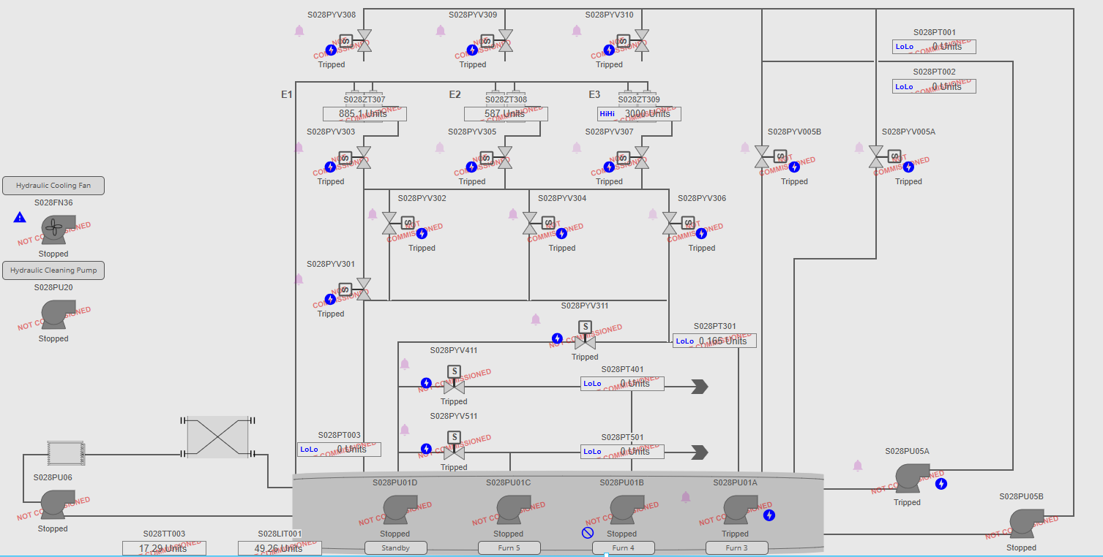

Transformer
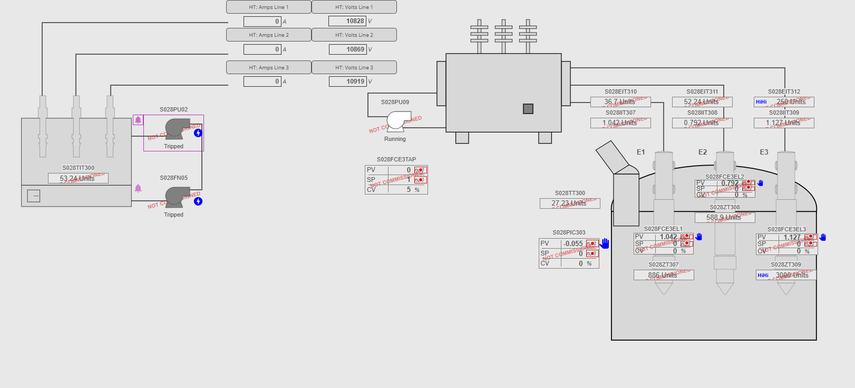

Slag Granulation
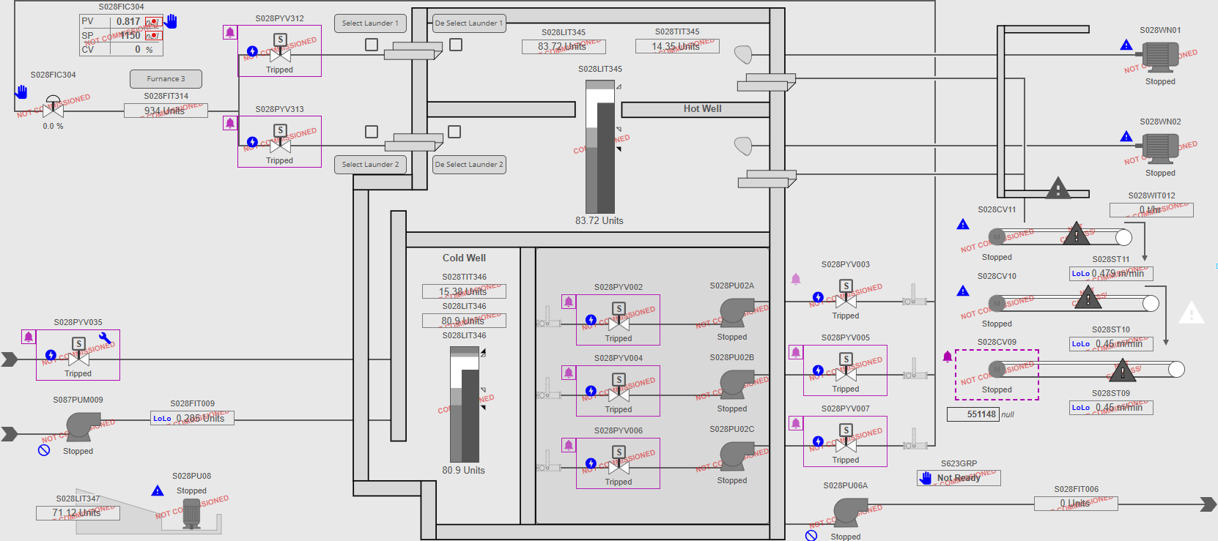

Pyro Furnance 4

Control
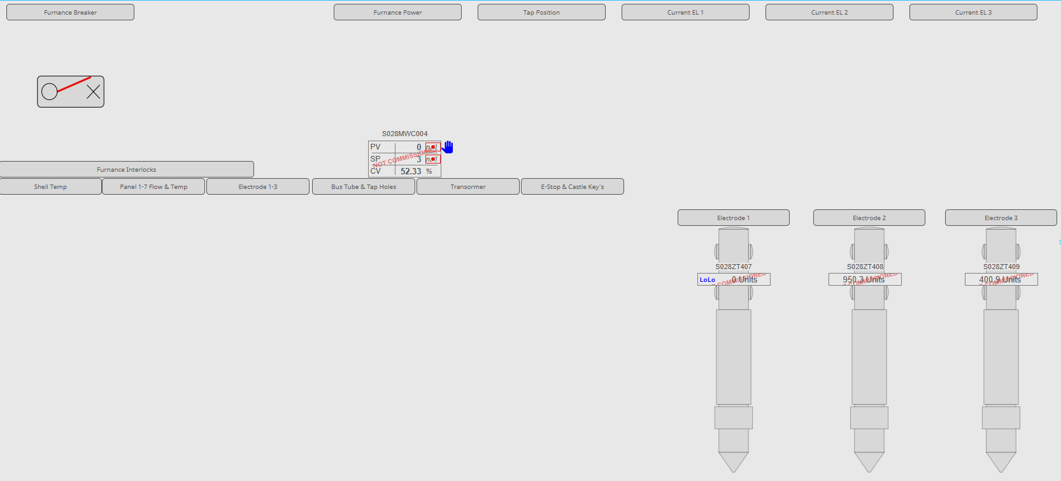

Temperatures
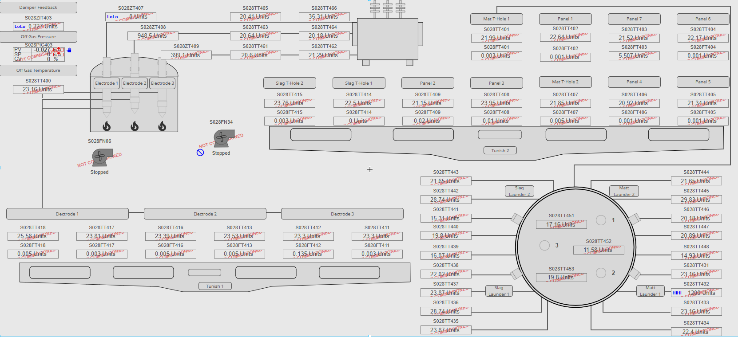

Hydraulics Pack
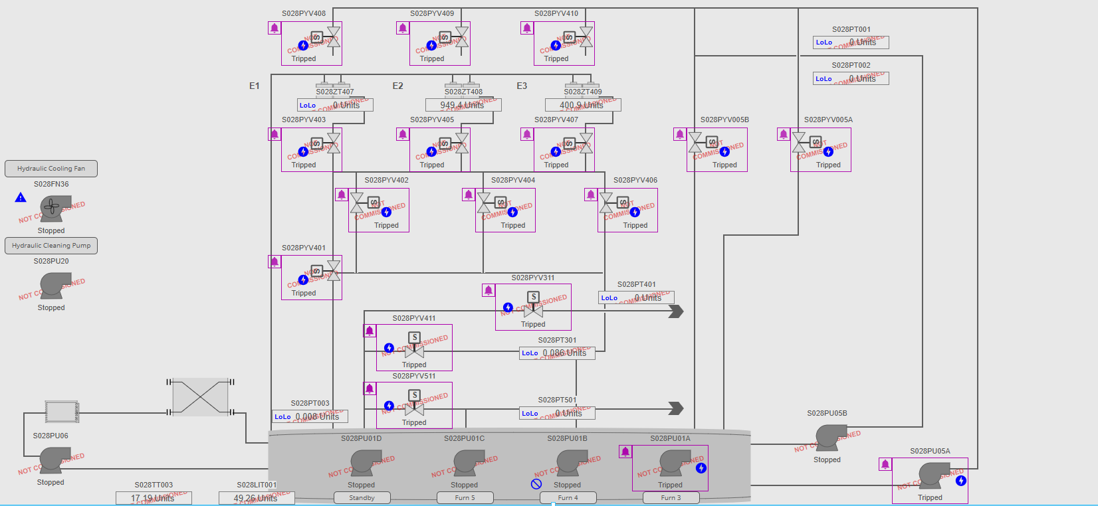

Transformer
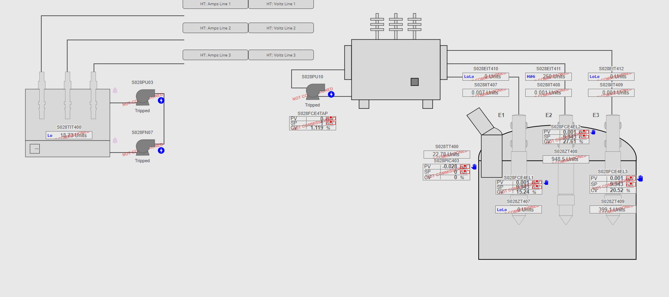

Slag Granulation
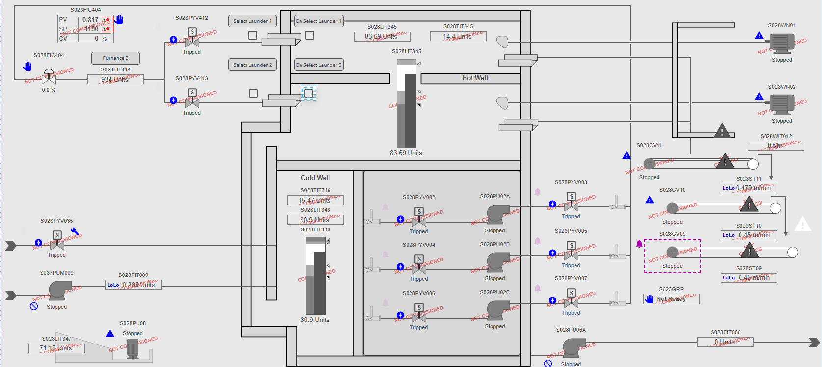

Pyro Furnance 5

Control
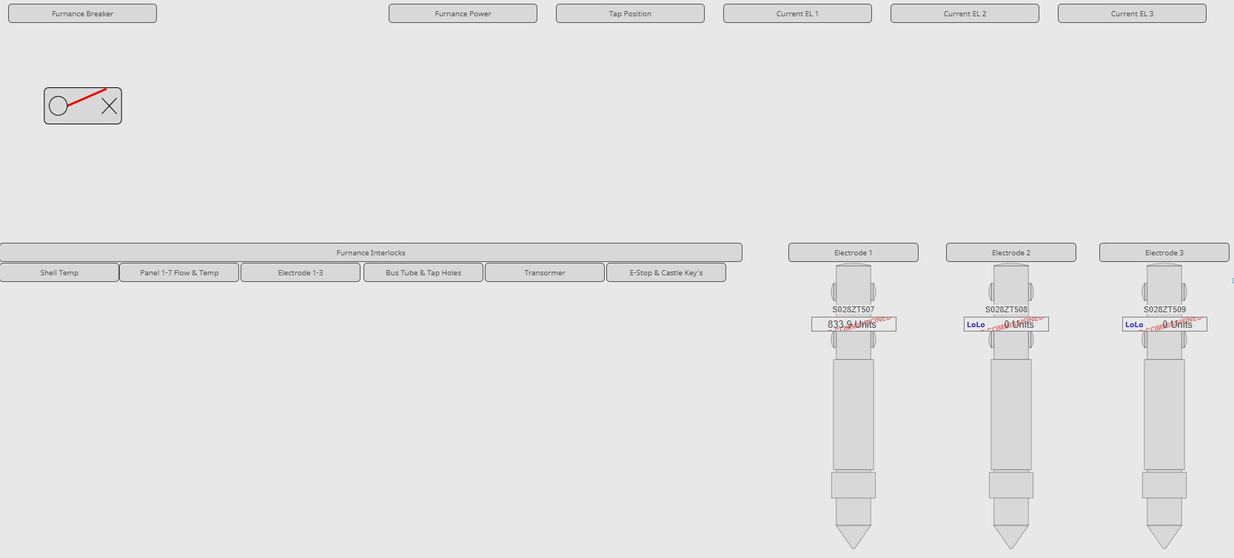

Temperatures
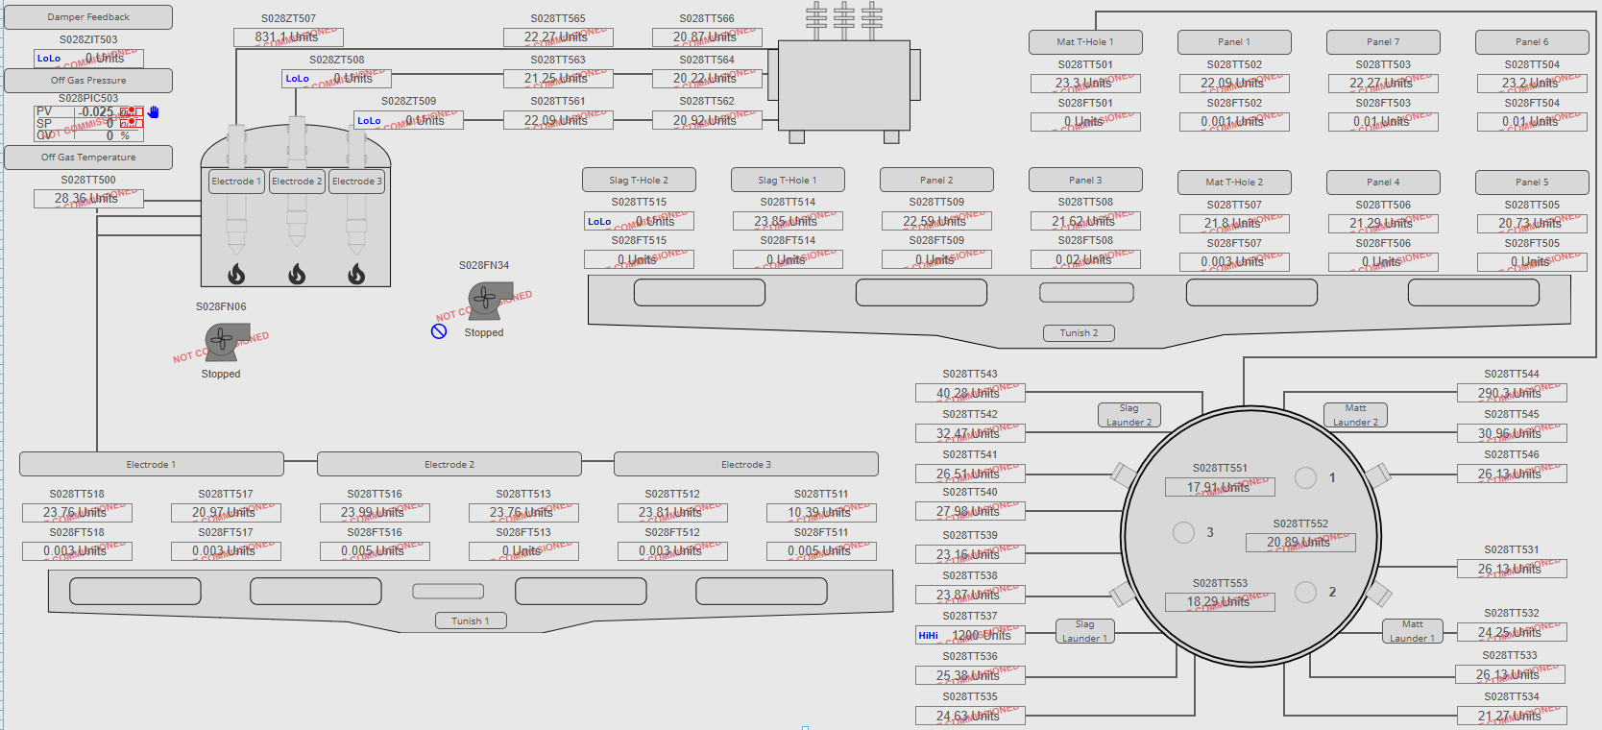

Hydraulic Pack
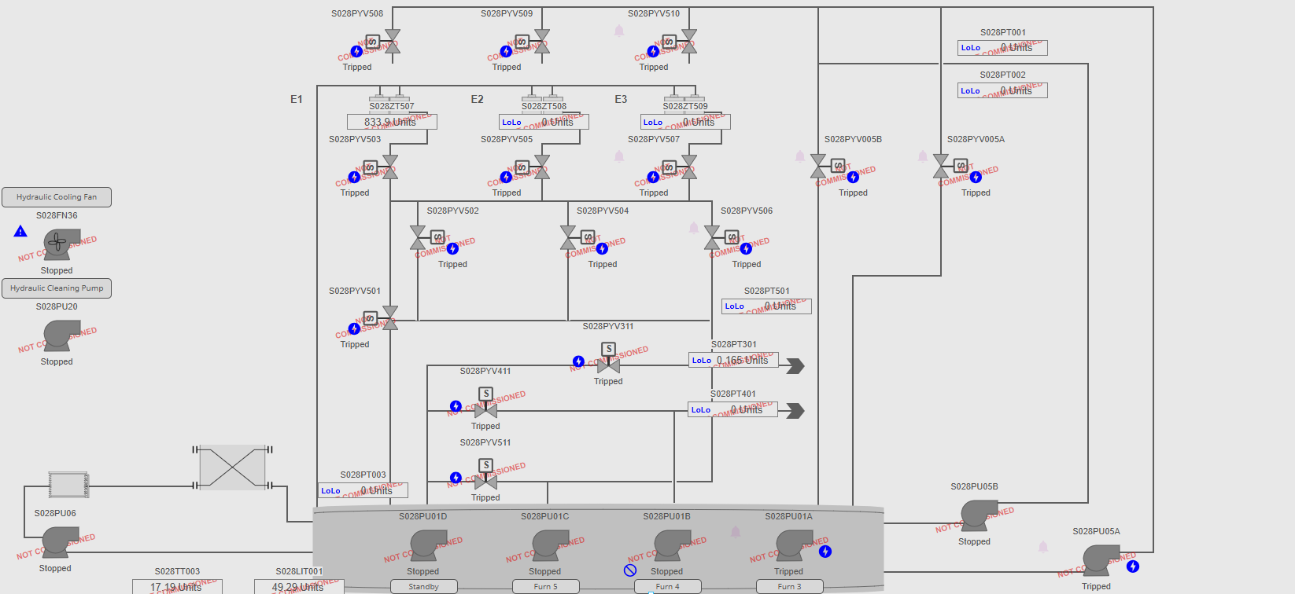

Transformer
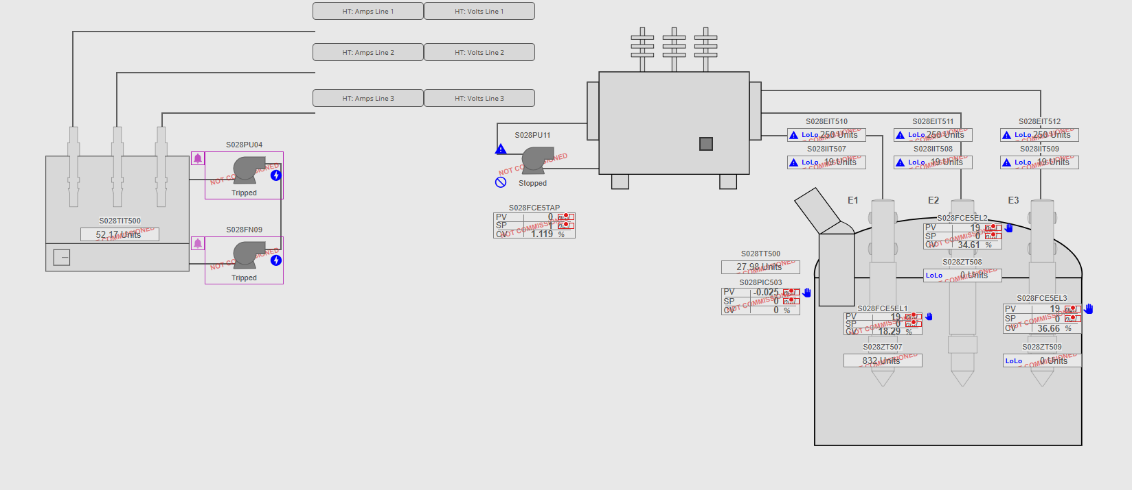

Slag Granulation
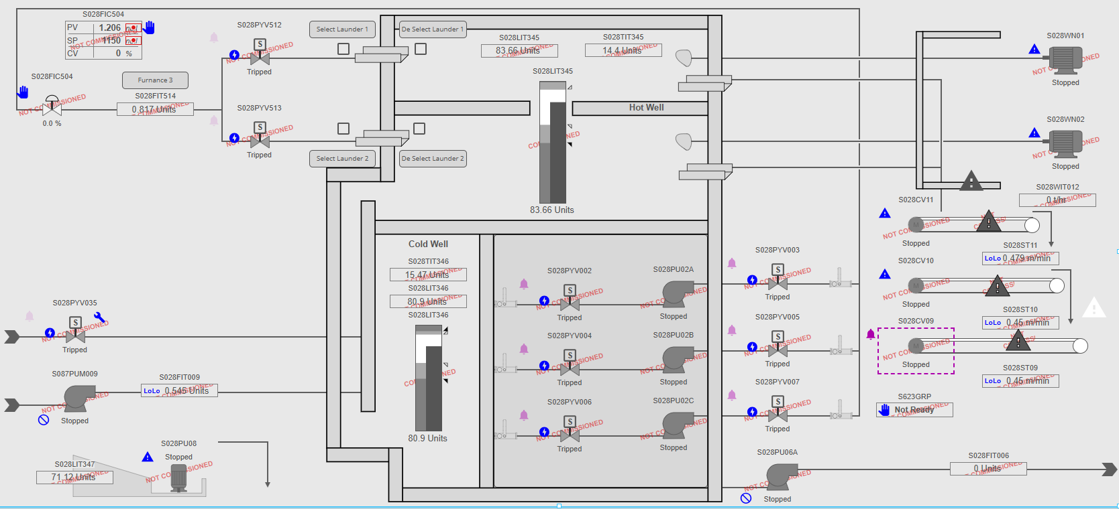

Utilities

Conc Silo
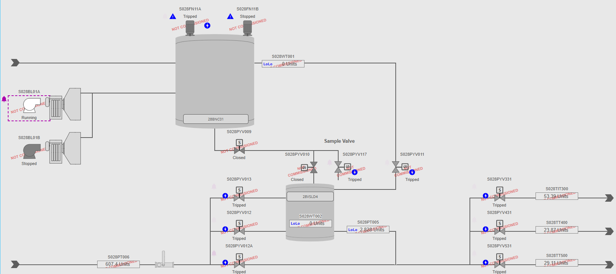

Lime Pyro Feed
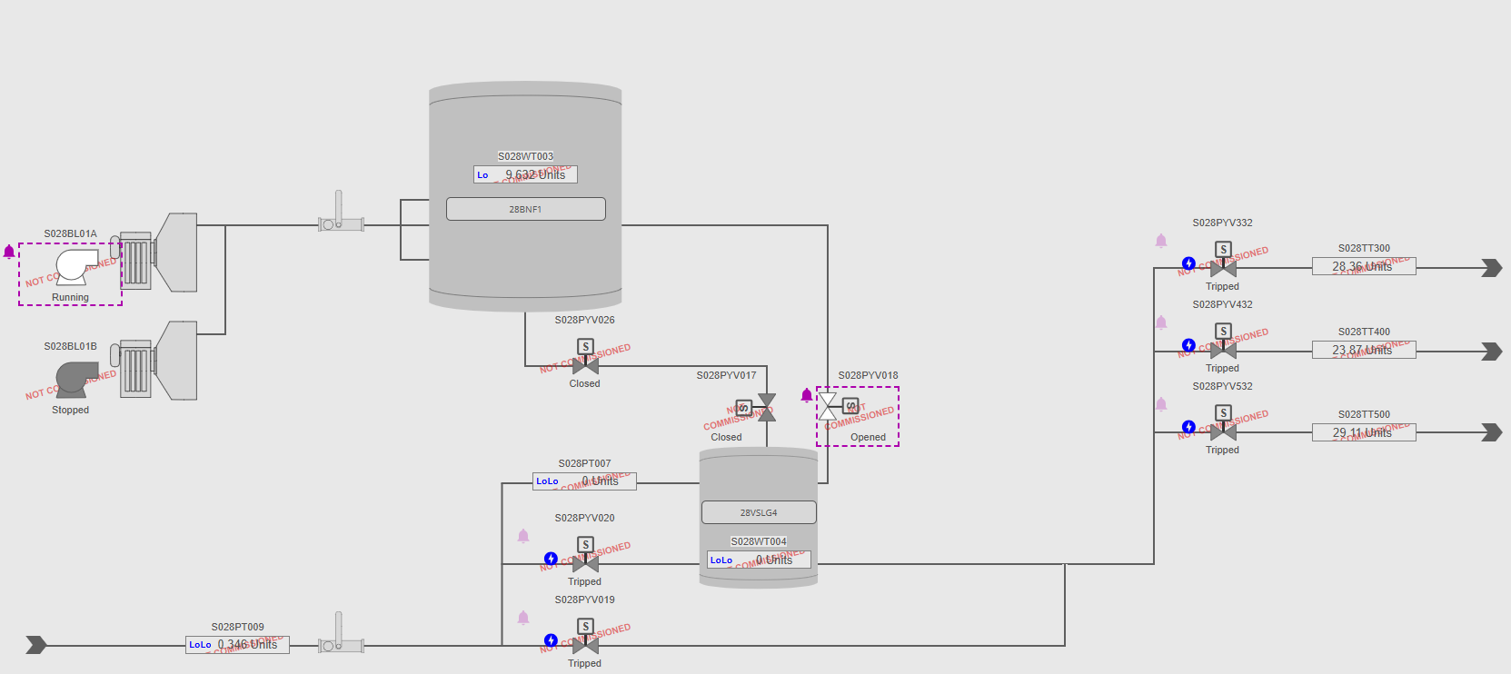

Conc Vessel
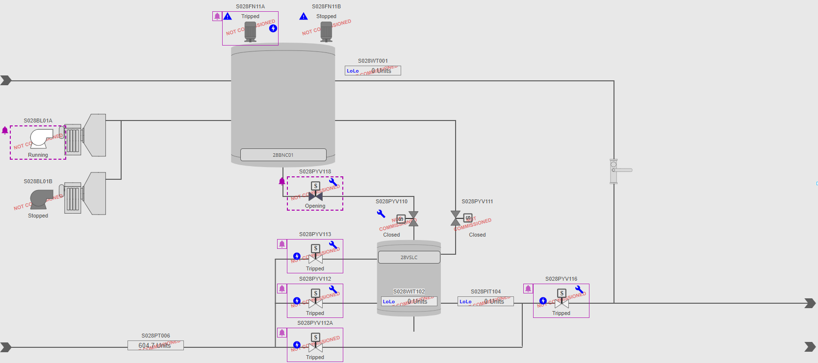

Cooling
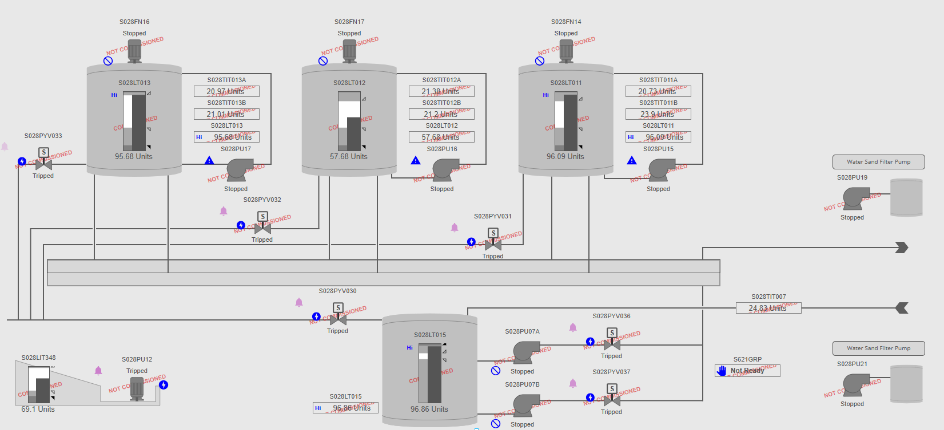

Lime Feeding Furnance 2
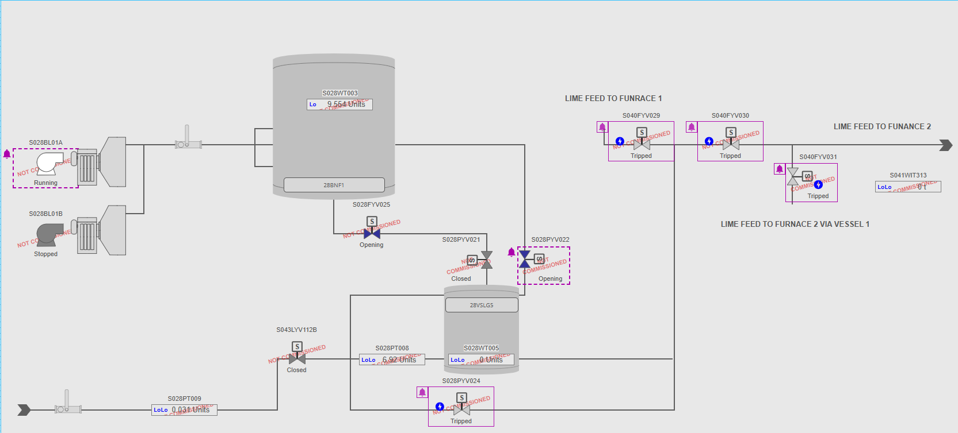

Conveyor Monitoring
